Switch to Renewable Energy and Save Money!
A few years ago, Pennsylvania deregulated its energy market. What this means is that you can choose which company you buy your energy from, it does not have to be PECO who creates your energy. This is great because this gives the consumer a choice to buy green energy if they would like. As long as you are still “on the grid,” PECO still does need to be your energy distributor. This means that they get the energy to your house.
Here you can see the generation charge on my bill. It makes up approximately half of the bill. If you sign up for PECO’s smart energy program, you can receive a discount on this part of the bill.
Sign me up!
The Quick, Simple, Cheap Way…
PECO has a Standard Offer Program. It offers a fixed-rate price at 7% below PECO’s current price, for a term of one-year with no cancellation or termination fees. Save money and the environment!*
Currently, Green Mountain Energy* is the only participant in this program that supplies clean electricity. Simply follow these steps:
- Have your PECO bill or account number ready
- Call PECO Smart Energy at 1-888-899-8612
- Ask to switch to Green Mountain
- They will walk you through the steps to sign up.
- You will be notified 45-60 days before your contract expires, but mark your calendar for the end of the 1-year term to be sure to sign up again or choose another option
*Although 100% of Green Mountain Energy is renewable, a fair amount of the actual energy that goes to your house still will have been produced by non-renewable resources. By switching to a company like Green Mountain Energy (and most around here), you are buying Renewable Energy Credits/Certificates or RECs. RECs are explained on the back of this page. Don’t let RECs get you down! RECs are a great way to make renewable energy more mainstream and for you to do your part to lower your carbon emissions!
**Disclaimer: Companies are neither endorsed nor recommend. It is possible that other green energy suppliers will join, so you may ask to see if a company you like is on the plan.

Customize Your Plan…
Is it important for you to choose unique features, such as buying energy from an independently owned company, a co-op, or from local wind?
You can do so by using www.PApowerswitch.com and choose a plan. PA Power Switch is a unique tool that will help you find a list of electricity suppliers. Choose “Residential,” be sure to filter for renewable, then double check it is 100% renewable. You may also want to select “fixed rate,” “no cancellation fee,” and “no monthly charge.” Once you narrow down your choices, if you wish to, you can learn about the features of each supplier by visiting their websites.

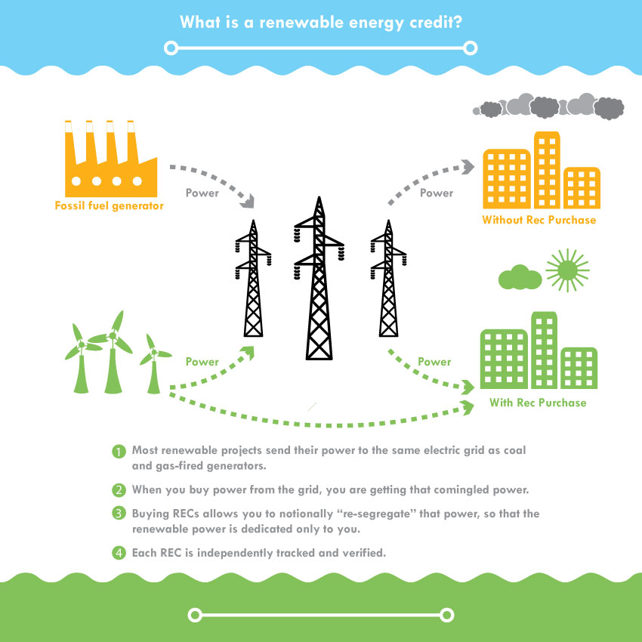
What are Renewable Energy Credits/ Certificates (RECs)?
Why Purchase RECs?
In an ideal world, we would all have small wind farms or solar panels that generate exactly the amount of energy we need to power our lives. But let’s face it, that’s pretty tough to do. By purchasing RECs, you are supporting clean energy and displacing emissions associated with fossil fuel-powered electric generation.
Diagram and explanation are from:
https://www.terrapass.com/climate-change/climate-changerenewable-energy-credits

Here is a link to a video from The Center for Resource Solutions, which does an excellent job of explaining how RECs work.
https://www.youtube.com/watch?v=opJMrzNauFQ

